Daniel Cody

Professor Labouseur

Database Systems

12 November 2014

Lab 9:

1.

Players:

PlayerID -> PersonID, TeamID, Age

Teams:

TeamID -> AgeID, Name

Person:

PersonID -> Name, Address, Phone Number

Coaches:

CoachID -> PersonID, YearsCoached

AssistantCoach:

acID -> CoachID

HeadCoach:

hcID -> CoachID

TeamCoached:

TCID ->CoachID, TeamID

AgeGroup:

AgeID -> Ages

2.

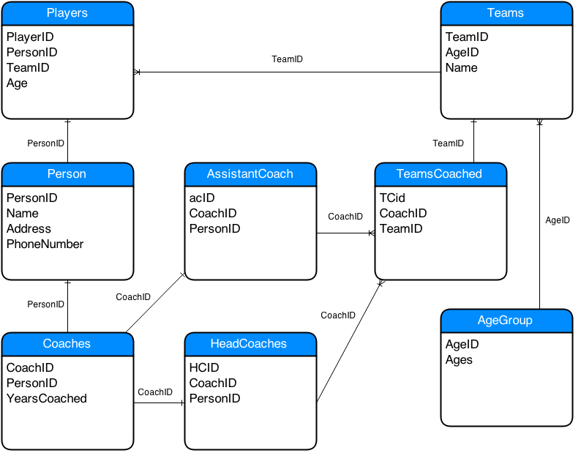

3.

This database is in third normal form because it is in second normal form and all attributes in the tables rely on the primary key. The database is in second normal form because it is in first normal form and no non-prime attribute relies on the primary key or the composite key. The database is in first normal form because each attribute only contains atomic values.